-----------------------------------------X--------------------------------------------

**How Thread Works?**

Java 8 Concurrency tutorial.

* you learn how to execute code in parallel via threads, tasks and executor services.
* Part 1: Threads and Executors
* Part 2: [Synchronization and Locks](https://winterbe.com/posts/2015/04/30/java8-concurrency-tutorial-synchronized-locks-examples/)
* Part 3: [Atomic Variables and ConcurrentMap](https://winterbe.com/posts/2015/05/22/java8-concurrency-tutorial-atomic-concurrent-map-examples/)

-------------------------------------------------------X-------------------------------------------------

* The [Concurrency API](https://docs.oracle.com/javase/8/docs/api/java/util/concurrent/package-summary.html) was first introduced with the release of Java 5 and then progressively enhanced with every new Java release.
* Threads and Runnables[#](https://winterbe.com/posts/2015/04/07/java8-concurrency-tutorial-thread-executor-examples/" \l "threads-and-runnables" \o "Permalink to this section)- All modern operating systems support concurrency both via [processes](http://en.wikipedia.org/wiki/Process_(computing)) and [threads](http://en.wikipedia.org/wiki/Thread_%28computing%29).
* Processes are instances of programs which typically run independent to each other, e.g. if you start a java program the operating system spawns a new process which runs in parallel to other programs.
* Inside those processes we can utilize threads to execute code concurrently, so we can make the most out of the available cores of the CPU.
* Java supports [Threads](https://docs.oracle.com/javase/8/docs/api/java/lang/Thread.html) since JDK 1.0. Before starting a new thread, you have to specify the code to be executed by this thread, often called the task.
* This is done by implementing Runnable - a functional interface defining a single void no-args method run() as demonstrated in the following example:

Runnable task = () -> {

String threadName = Thread.currentThread().getName();

System.out.println("Hello " + threadName);

};

task.run();

Thread thread = new Thread(task);

thread.start();

System.out.println("Done!");

* Since Runnable is a functional interface we can utilize Java 8 lambda expressions to print the current threads name to the console.
* First we execute the runnable directly on the main thread before starting a new thread.
* The result on the console might look like this:

Hello main

Hello Thread-0

Done!

Or that:

Hello main

Done!

Hello Thread-0

* Due to concurrent execution we cannot predict if the runnable will be invoked before or after printing 'done'. The order is non-deterministic, thus making concurrent programming a complex task in larger applications.
* Threads can be put to sleep for a certain duration. This is quite handy to simulate long running tasks in the subsequent code samples of this article:

Runnable runnable = () -> {

try {

String name = Thread.currentThread().getName();

System.out.println("Foo " + name);

TimeUnit.SECONDS.sleep(1);

System.out.println("Bar " + name);

}

catch (InterruptedException e) {

e.printStackTrace();

}

};

Thread thread = new Thread(runnable);

thread.start();

* When you run the above code you'll notice the one second delay between the first and the second print statement.
* TimeUnit is a useful enum for working with units of time. Alternatively you can achieve the same by calling Thread.sleep(1000).
* Working with the Thread class can be very tedious and error-prone. Due to that reason the **Concurrency API** has been introduced back in 2004 with the release of Java 5.
* The API is located in package java.util.concurrent and contains many useful classes for handling concurrent programming.
* Since that time the Concurrency API has been enhanced with every new Java release and even Java 8 provides new classes and methods for dealing with concurrency.
* Now let's take a deeper look at one of the most important parts of the Concurrency API - the executor services.
* Executors-The Concurrency API introduces the concept of an ExecutorService as a higher level replacement for working with threads directly.
* Executors are capable of running asynchronous tasks and typically manage a pool of threads, so we don't have to create new threads manually.
* All threads of the internal pool will be reused under the hood for revenant tasks, so we can run as many concurrent tasks as we want throughout the life-cycle of our application with a single executor service.
* This is how the first thread-example looks like using executors:

ExecutorService executor = Executors.newSingleThreadExecutor();

executor.submit(() -> {

String threadName = Thread.currentThread().getName();

System.out.println("Hello " + threadName);

});

// => Hello pool-1-thread-1

* The class Executors provides convenient factory methods for creating different kinds of executor services.
* In this sample we use an executor with a thread pool of size one.
* The result looks similar to the above sample but when running the code you'll notice an important difference: the java process never stops!
* Executors have to be stopped explicitly - otherwise they keep listening for new tasks.
* An ExecutorService provides two methods for that purpose: shutdown() waits for currently running tasks to finish while shutdownNow() interrupts all running tasks and shut the executor down immediately.
* This is the preferred way how I typically shutdown executors:

try {

System.out.println("attempt to shutdown executor");

executor.shutdown();

executor.awaitTermination(5, TimeUnit.SECONDS);

}

catch (InterruptedException e) {

System.err.println("tasks interrupted");

}

finally {

if (!executor.isTerminated()) {

System.err.println("cancel non-finished tasks");

}

executor.shutdownNow();

System.out.println("shutdown finished");

}

* The executor shuts down softly by waiting a certain amount of time for termination of currently running tasks.
* After a maximum of five seconds the executor finally shuts down by interrupting all running tasks.
* Callables and Futures-In addition to Runnable executors support another kind of task named Callable.
* Callables are functional interfaces just like Runnables but instead of being void they return a value.
* This lambda expression defines a callable returning an integer after sleeping for one second:

Callable<Integer> task = () -> {

try {

TimeUnit.SECONDS.sleep(1);

return 123;

}

catch (InterruptedException e) {

throw new IllegalStateException("task interrupted", e);

}

};

* Callables can be submitted to executor services just like runnables.
* But what about the callables result? Since submit() doesn't wait until the task completes,
* the executor service cannot return the result of the callable directly. Instead the executor returns a special result of type Future which can be used to retrieve the actual result at a later point in time.

ExecutorService executor = Executors.newFixedThreadPool(1);

Future<Integer> future = executor.submit(task);

System.out.println("future done? " + future.isDone());

Integer result = future.get();

System.out.println("future done? " + future.isDone());

System.out.print("result: " + result);

* After submitting the callable to the executor we first check if the future has already been finished execution via isDone().
* I'm pretty sure this isn't the case since the above callable sleeps for one second before returning the integer.
* Calling the method get() blocks the current thread and waits until the callable completes before returning the actual result 123.
* Now the future is finally done and we see the following result on the console:

future done? false

future done? true

result: 123

* Futures are tightly coupled to the underlying executor service. Keep in mind that every non-terminated future will throw exceptions if you shutdown the executor:

executor.shutdownNow();

future.get();

* You might have noticed that the creation of the executor slightly differs from the previous example.
* We use newFixedThreadPool(1) to create an executor service backed by a thread-pool of size one. This is equivalent to newSingleThreadExecutor() but we could later increase the pool size by simply passing a value larger than one.
* Timeouts-Any call to future.get() will block and wait until the underlying callable has been terminated. In the worst case a callable runs forever - thus making your application unresponsive. You can simply counteract those scenarios by passing a timeout:

ExecutorService executor = Executors.newFixedThreadPool(1);

Future<Integer> future = executor.submit(() -> {

try {

TimeUnit.SECONDS.sleep(2);

return 123;

}

catch (InterruptedException e) {

throw new IllegalStateException("task interrupted", e);

}

});

future.get(1, TimeUnit.SECONDS);

* Executing the above code results in a TimeoutException:

Exception in thread "main" java.util.concurrent.TimeoutException

at java.util.concurrent.FutureTask.get(FutureTask.java:205)

* You might already have guessed why this exception is thrown: We specified a maximum wait time of one second but the callable actually needs two seconds before returning the result.
* InvokeAll-Executors support batch submitting of multiple callables at once via invokeAll().
* This method accepts a collection of callables and returns a list of futures.

ExecutorService executor = Executors.newWorkStealingPool();

List<Callable<String>> callables = Arrays.asList(

() -> "task1",

() -> "task2",

() -> "task3");

executor.invokeAll(callables)

.stream()

.map(future -> {

try {

return future.get();

}

catch (Exception e) {

throw new IllegalStateException(e);

}

})

.forEach(System.out::println);

* In this example we utilize Java 8 functional streams in order to process all futures returned by the invocation of invokeAll.
* We first map each future to its return value and then print each value to the console
* InvokeAny-Another way of batch-submitting callables is the method invokeAny() which works slightly different to invokeAll().
* Instead of returning future objects this method blocks until the first callable terminates and returns the result of that callable.
* In order to test this behaviour we use this helper method to simulate callables with different durations. The method returns a callable that sleeps for a certain amount of time until returning the given result:

Callable<String> callable(String result, long sleepSeconds) {

return () -> {

TimeUnit.SECONDS.sleep(sleepSeconds);

return result;

};

}

* We use this method to create a bunch of callables with different durations from one to three seconds.
* Submitting those callables to an executor via invokeAny() returns the string result of the fastest callable - in that case task2:

ExecutorService executor = Executors.newWorkStealingPool();

List<Callable<String>> callables = Arrays.asList(

callable("task1", 2),

callable("task2", 1),

callable("task3", 3));

String result = executor.invokeAny(callables);

System.out.println(result);

// => task2

* The above example uses yet another type of executor created via newWorkStealingPool().
* This factory method is part of Java 8 and returns an executor of type ForkJoinPool which works slightly different than normal executors.
* Instead of using a fixed size thread-pool [ForkJoinPools](https://docs.oracle.com/javase/8/docs/api/java/util/concurrent/ForkJoinPool.html) are created for a given parallelism size which per default is the number of available cores of the hosts CPU.
* ForkJoinPools exist since Java 7
* Scheduled Executors- In order to periodically run common tasks multiple times, we can utilize scheduled thread pools.
* A ScheduledExecutorService is capable of scheduling tasks to run either periodically or once after a certain amount of time has elapsed.
* This code sample schedules a task to run after an initial delay of three seconds has passed:

ScheduledExecutorService executor = Executors.newScheduledThreadPool(1);

Runnable task = () -> System.out.println("Scheduling: " + System.nanoTime());

ScheduledFuture<?> future = executor.schedule(task, 3, TimeUnit.SECONDS);

TimeUnit.MILLISECONDS.sleep(1337);

long remainingDelay = future.getDelay(TimeUnit.MILLISECONDS);

System.out.printf("Remaining Delay: %sms", remainingDelay);

* Scheduling a task produces a specialized future of type ScheduledFuture which - in addition to Future - provides the method getDelay() to retrieve the remaining delay.
* After this delay has elapsed the task will be executed concurrently.
* In order to schedule tasks to be executed periodically, executors provide the two methods scheduleAtFixedRate() and scheduleWithFixedDelay().
* The first method is capable of executing tasks with a fixed time rate, e.g. once every second as demonstrated in this example:

ScheduledExecutorService executor = Executors.newScheduledThreadPool(1);

Runnable task = () -> System.out.println("Scheduling: " + System.nanoTime());

int initialDelay = 0;

int period = 1;

executor.scheduleAtFixedRate(task, initialDelay, period, TimeUnit.SECONDS);

* Additionally this method accepts an initial delay which describes the leading wait time before the task will be executed for the first time.
* Please keep in mind that scheduleAtFixedRate() doesn't take into account the actual duration of the task.
* So if you specify a period of one second but the task needs 2 seconds to be executed then the thread pool will working to capacity very soon.
* In that case you should consider using scheduleWithFixedDelay() instead.
* This method works just like the counterpart described above.
* The difference is that the wait time period applies between the end of a task and the start of the next task. For example:

ScheduledExecutorService executor = Executors.newScheduledThreadPool(1);

Runnable task = () -> {

try {

TimeUnit.SECONDS.sleep(2);

System.out.println("Scheduling: " + System.nanoTime());

}

catch (InterruptedException e) {

System.err.println("task interrupted");

}

};

executor.scheduleWithFixedDelay(task, 0, 1, TimeUnit.SECONDS);

* This example schedules a task with a fixed delay of one second between the end of an execution and the start of the next execution.
* The initial delay is zero and the tasks duration is two seconds. So we end up with an execution interval of 0s, 3s, 6s, 9s and so on.
* As you can see scheduleWithFixedDelay() is handy if you cannot predict the duration of the scheduled tasks.

**-------------------------------------------X----------------------------------------------------------**

**How Array List Works?**

Ans:- **Amortized complexity is** the total expense per operation, evaluated over a sequence of operations.

* The idea is to guarantee the total expense of the entire sequence, while permitting individual operations to be much more expensive than the amortized cost.
* **Example:**  
  onsider a [dynamic array](https://en.wikipedia.org/wiki/Dynamic_array) that grows in size as more elements are added to it, such as ArrayList in Java or std::vector in C++. If we started out with a dynamic array of size 4, we could push 4 elements onto it, and each operation would take [constant time](https://en.wikipedia.org/wiki/Constant_time). Yet pushing a fifth element onto that array would take longer as the array would have to create a new array of double the current size (8), copy the old elements onto the new array, and then add the new element. The next three push operations would similarly take constant time, and then the subsequent addition would require another slow doubling of the array size.
* In general if we consider an arbitrary number of pushes *n* + 1 to an array of size *n*, we notice that push operations take constant time except for the last one which takes [{\displaystyle \Theta (n)}](https://en.wikipedia.org/wiki/Big_O_notation) time to perform the size doubling operation. Since there were *n* + 1 operations total we can take the average of this and find that pushing elements onto the dynamic array takes: {\displaystyle {\tfrac {n\Theta (1)+\Theta (n)}{n+1}}=\Theta (1)}, constant time.[[4]](https://en.wikipedia.org/wiki/Amortized_analysis#cite_note-Lecture_20-4)
* Resizable-array implementation of the List interface. Implements all optional list operations, and permits all elements, including null. In addition to implementing the List interface, this class provides methods to manipulate the size of the array that is used internally to store the list. (This class is roughly equivalent to Vector, except that it is unsynchronized.)
* The size, isEmpty, get, set, iterator, and listIterator operations run in constant time. The add operation runs in *amortized constant time*, that is, adding n elements requires O(n) time. All of the other operations run in linear time (roughly speaking). The constant factor is low compared to that for the LinkedList implementation.
* Each ArrayList instance has a *capacity*. The capacity is the size of the array used to store the elements in the list. It is always at least as large as the list size. As elements are added to an ArrayList, its capacity grows automatically. The details of the growth policy are not specified beyond the fact that adding an element has constant amortized time cost.
* An application can increase the capacity of an ArrayList instance before adding a large number of elements using the ensureCapacity operation. This may reduce the amount of incremental reallocation.
* **Note that this implementation is not synchronized.** If multiple threads access an ArrayList instance concurrently, and at least one of the threads modifies the list structurally, it *must* be synchronized externally. (A structural modification is any operation that adds or deletes one or more elements, or explicitly resizes the backing array; merely setting the value of an element is not a structural modification.) This is typically accomplished by synchronizing on some object that naturally encapsulates the list. If no such object exists, the list should be "wrapped" using the [Collections.synchronizedList](https://docs.oracle.com/javase/8/docs/api/java/util/Collections.html#synchronizedList-java.util.List-) method. This is best done at creation time, to prevent accidental unsynchronized access to the list:

List list = Collections.synchronizedList(new ArrayList(...));

* The iterators returned by this class's [iterator](https://docs.oracle.com/javase/8/docs/api/java/util/ArrayList.html#iterator--) and [listIterator](https://docs.oracle.com/javase/8/docs/api/java/util/ArrayList.html#listIterator-int-) methods are *fail-fast*: if the list is structurally modified at any time after the iterator is created, in any way except through the iterator's own [remove](https://docs.oracle.com/javase/8/docs/api/java/util/ListIterator.html#remove--) or [add](https://docs.oracle.com/javase/8/docs/api/java/util/ListIterator.html#add-E-) methods, the iterator will throw a [ConcurrentModificationException](https://docs.oracle.com/javase/8/docs/api/java/util/ConcurrentModificationException.html). Thus, in the face of concurrent modification, the iterator fails quickly and cleanly, rather than risking arbitrary, non-deterministic behavior at an undetermined time in the future.
* Note that the fail-fast behavior of an iterator cannot be guaranteed as it is, generally speaking, impossible to make any hard guarantees in the presence of unsynchronized concurrent modification. Fail-fast iterators throw ConcurrentModificationException on a best-effort basis. Therefore, it would be wrong to write a program that depended on this exception for its correctness: *the fail-fast behavior of iterators should be used only to detect bugs.*

---------------------------------------X----------------------------------------------

**What is Failfase and Fail safe?**

Ans-**Fail**-**Safe**. 1. Exception. Any changes in the collection, such as adding, removing and updating collection during a thread are iterating collection then **Fail fast** throw concurrent modification exception.

* The **fail**-**safe** collection doesn't throw exception
* in [systems design](https://en.wikipedia.org/wiki/Systems_design), a **fail-fast** system is one which immediately reports at its interface any condition that is likely to indicate a failure. Fail-fast systems are usually designed to stop normal operation rather than attempt to continue a possibly flawed process. Such designs often check the system's state at several points in an operation, so any failures can be detected early. The responsibility of a fail-fast module is detecting errors, then letting the next-highest level of the system handle them.

**What is Java ClassLoader?**

We know that Java Program runs on [Java Virtual Machine](https://www.digitalocean.com/community/tutorials/difference-jdk-vs-jre-vs-jvm) (JVM). When we compile a Java Class, JVM creates the bytecode, which is platform and machine-independent. The bytecode is stored in a **.class file**. When we try to use a class, the ClassLoader loads it into the memory.

**Built-in ClassLoader Types**

There are three types of built-in ClassLoader in Java.

1. **Bootstrap Class Loader** – It loads JDK internal classes. It loads rt.jar and other core classes for example java.lang.* package classes.
2. **Extensions Class Loader** – It loads classes from the JDK extensions directory, usually $JAVA_HOME/lib/ext directory.
3. **System Class Loader** – This classloader loads classes from the current classpath. We can set classpath while invoking a program using -cp or -classpath command line option.

**ClassLoader Hierarchy**

ClassLoader is hierarchical in loading a class into memory. Whenever a request is raised to load a class, it delegates it to the parent classloader. This is how uniqueness is maintained in the runtime environment. If the parent class loader doesn’t find the class then the class loader itself tries to load the class. Let’s understand this by executing the below java program.

package com.journaldev.classloader;

public class ClassLoaderTest {

public static void main(String[] args) {

System.out.println("class loader for HashMap: "

+ java.util.HashMap.class.getClassLoader());

System.out.println("class loader for DNSNameService: "

+ sun.net.spi.nameservice.dns.DNSNameService.class

.getClassLoader());

System.out.println("class loader for this class: "

+ ClassLoaderTest.class.getClassLoader());

System.out.println(com.mysql.jdbc.Blob.class.getClassLoader());

}

}

Output:

class loader for HashMap: null

class loader for DNSNameService: sun.misc.Launcher$ExtClassLoader@7c354093

class loader for this class: sun.misc.Launcher$AppClassLoader@64cbbe37

sun.misc.Launcher$AppClassLoader@64cbbe37

**How Java ClassLoader Works?**

Let’s understand the working of class loaders from the above program output.

* The [java.util.HashMap](https://www.digitalocean.com/community/tutorials/java-hashmap) ClassLoader is coming as null, which reflects Bootstrap ClassLoader. The DNSNameService class ClassLoader is ExtClassLoader. Since the class itself is in CLASSPATH, System ClassLoader loads it.
* When we are trying to load HashMap, our System ClassLoader delegates it to the Extension ClassLoader. The extension class loader delegates it to the Bootstrap ClassLoader. The bootstrap class loader finds the HashMap class and loads it into the JVM memory.
* The same process is followed for the DNSNameService class. But, the Bootstrap ClassLoader is not able to locate it since it’s in $JAVA_HOME/lib/ext/dnsns.jar. Hence, it gets loaded by Extensions Classloader.
* The Blob class is included in the MySql [JDBC](https://www.digitalocean.com/community/tutorials/jdbc-tutorial) Connector jar (mysql-connector-java-5.0.7-bin.jar), which is present in the build path of the project. It’s also getting loaded by the System Classloader.
* The classes loaded by a child class loader have visibility into classes loaded by its parent class loaders. So classes loaded by System Classloader have visibility into classes loaded by Extensions and Bootstrap Classloader.
* If there are sibling class loaders then they can’t access classes loaded by each other.

**Why write a Custom ClassLoader in Java?**

Java default ClassLoader can load classes from the local file system, which is good enough for most of the cases. But, if you are expecting a class at the runtime or from the FTP server or via third party web service at the time of loading the class, then you have to extend the existing class loader. For example, AppletViewers load the classes from a remote web server.

**Java ClassLoader Methods**

* When JVM requests for a class, it invokes loadClass() function of the ClassLoader by passing the fully classified name of the Class.
* The loadClass() function calls the findLoadedClass() method to check that the class has been already loaded or not. It’s required to avoid loading the same class multiple times.
* If the Class is not already loaded, then it will delegate the request to parent ClassLoader to load the class.
* If the parent ClassLoader doesn’t find the class then it will invoke findClass() method to look for the classes in the file system.

**Java Custom ClassLoader Example**

We will create our own ClassLoader by extending the ClassLoader class and overriding the loadClass(String name) method. If the class name will start from com.journaldev then we will load it using our custom class loader or else we will invoke the parent ClassLoader loadClass() method to load the class.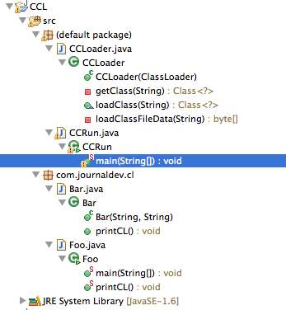

**1. CCLoader.java**

This is our custom class loader with below methods.

1. private byte[] loadClassFileData(String name): This method will read the class file from file system to byte array.
2. private Class<?> getClass(String name): This method will call the loadClassFileData() function and by invoking the parent defineClass() method, it will generate the Class and return it.
3. public Class<?> loadClass(String name): This method is responsible for loading the class. If the class name starts with com.journaldev (Our sample classes) then it will load it using getClass() method or else it will invoke the parent loadClass() function to load it.
4. public CCLoader(ClassLoader parent): This is the constructor, which is responsible for setting the parent ClassLoader.

import java.io.DataInputStream;

import java.io.File;

import java.io.IOException;

import java.io.InputStream;

/**

* Our Custom ClassLoader to load the classes. Any class in the com.journaldev

* package will be loaded using this ClassLoader. For other classes, it will delegate the request to its Parent ClassLoader.

*

*/

public class CCLoader extends ClassLoader {

/**

* This constructor is used to set the parent ClassLoader

*/

public CCLoader(ClassLoader parent) {

super(parent);

}

/**

* Loads the class from the file system. The class file should be located in

* the file system. The name should be relative to get the file location

*

* @param name

* Fully Classified name of the class, for example, com.journaldev.Foo

*/

private Class getClass(String name) throws ClassNotFoundException {

String file = name.replace('.', File.separatorChar) + ".class";

byte[] b = null;

try {

// This loads the byte code data from the file

b = loadClassFileData(file);

// defineClass is inherited from the ClassLoader class

// that converts byte array into a Class. defineClass is Final

// so we cannot override it

Class c = defineClass(name, b, 0, b.length);

resolveClass(c);

return c;

} catch (IOException e) {

e.printStackTrace();

return null;

}

}

/**

* Every request for a class passes through this method. If the class is in

* com.journaldev package, we will use this classloader or else delegate the

* request to parent classloader.

*

*

* @param name

* Full class name

*/

@Override

public Class loadClass(String name) throws ClassNotFoundException {

System.out.println("Loading Class '" + name + "'");

if (name.startsWith("com.journaldev")) {

System.out.println("Loading Class using CCLoader");

return getClass(name);

}

return super.loadClass(name);

}

/**

* Reads the file (.class) into a byte array. The file should be

* accessible as a resource and make sure that it's not in Classpath to avoid

* any confusion.

*

* @param name

* Filename

* @return Byte array read from the file

* @throws IOException

* if an exception comes in reading the file

*/

private byte[] loadClassFileData(String name) throws IOException {

InputStream stream = getClass().getClassLoader().getResourceAsStream(

name);

int size = stream.available();

byte buff[] = new byte[size];

DataInputStream in = new DataInputStream(stream);

in.readFully(buff);

in.close();

return buff;

}

}

**2. CCRun.java**

This is our test class with the [main function](https://www.digitalocean.com/community/tutorials/public-static-void-main-string-args-java-main-method). We are creating an instance of our ClassLoader and loading sample classes using its loadClass() method. After loading the class, we are using [Java Reflection API](https://www.digitalocean.com/community/tutorials/java-reflection-example-tutorial) to invoke its methods.

import java.lang.reflect.Method;

public class CCRun {

public static void main(String args[]) throws Exception {

String progClass = args[0];

String progArgs[] = new String[args.length - 1];

System.arraycopy(args, 1, progArgs, 0, progArgs.length);

CCLoader ccl = new CCLoader(CCRun.class.getClassLoader());

Class clas = ccl.loadClass(progClass);

Class mainArgType[] = { (new String[0]).getClass() };

Method main = clas.getMethod("main", mainArgType);

Object argsArray[] = { progArgs };

main.invoke(null, argsArray);

// Below method is used to check that the Foo is getting loaded

// by our custom class loader i.e CCLoader

Method printCL = clas.getMethod("printCL", null);

printCL.invoke(null, new Object[0]);

}

}

**3. Foo.java and Bar.java**

These are our test classes that are getting loaded by our custom classloader. They have a printCL() method, which is getting invoked to print the ClassLoader information. Foo class will be loaded by our custom class loader. Foo uses Bar class, so Bar class will also be loaded by our custom class loader.

package com.journaldev.cl;

public class Foo {

static public void main(String args[]) throws Exception {

System.out.println("Foo Constructor >>> " + args[0] + " " + args[1]);

Bar bar = new Bar(args[0], args[1]);

bar.printCL();

}

public static void printCL() {

System.out.println("Foo ClassLoader: "+Foo.class.getClassLoader());

}

}

package com.journaldev.cl;

public class Bar {

public Bar(String a, String b) {

System.out.println("Bar Constructor >>> " + a + " " + b);

}

public void printCL() {

System.out.println("Bar ClassLoader: "+Bar.class.getClassLoader());

}

}

**4. Java Custom ClassLoader Execution Steps**

First of all, we will compile all the classes through the command line. After that, we will run the CCRun class by passing three arguments. The first argument is the fully classified name for Foo class that will get loaded by our class loader. Other two arguments are passed along to the Foo class main function and Bar constructor. The execution steps and the output will be like below.

$ javac -cp . com/journaldev/cl/Foo.java

$ javac -cp . com/journaldev/cl/Bar.java

$ javac CCLoader.java

$ javac CCRun.java

CCRun.java:18: warning: non-varargs call of varargs method with inexact argument type for last parameter;

cast to java.lang.Class<?> for a varargs call

cast to java.lang.Class<?>[] for a non-varargs call and to suppress this warning

Method printCL = clas.getMethod("printCL", null);

^

1 warning

$ java CCRun com.journaldev.cl.Foo 1212 1313

Loading Class 'com.journaldev.cl.Foo'

Loading Class using CCLoader

Loading Class 'java.lang.Object'

Loading Class 'java.lang.String'

Loading Class 'java.lang.Exception'

Loading Class 'java.lang.System'

Loading Class 'java.lang.StringBuilder'

Loading Class 'java.io.PrintStream'

Foo Constructor >>> 1212 1313

Loading Class 'com.journaldev.cl.Bar'

Loading Class using CCLoader

Bar Constructor >>> 1212 1313

Loading Class 'java.lang.Class'

Bar ClassLoader: CCLoader@71f6f0bf

Foo ClassLoader: CCLoader@71f6f0bf

$

If you look at the output, it’s trying to load com.journaldev.cl.Foo class. Since it’s extending java.lang.Object class, it’s trying to load Object class first. So the request is coming to CCLoader loadClass method, which is delegating it to the parent class. So the parent class loaders are loading the Object, String, and other java classes. Our ClassLoader is only loading Foo and Bar class from the file system. It’s clear from the output of the printCL() function. We can change the loadClassFileData() functionality to read the byte array from FTP Server or by invoking any third party service to get the class byte array on the fly. I hope that the article will be useful in understanding Java ClassLoader working and how we can extend it to do a lot more than just taking it from the file system.

**Making Custom ClassLoader as Default ClassLoader**

We can make our custom class loader as the default one when JVM starts by using Java Options. For example, I will run the ClassLoaderTest program once again after providing the java classloader option.

$ javac -cp .:../lib/mysql-connector-java-5.0.7-bin.jar com/journaldev/classloader/ClassLoaderTest.java

$ java -cp .:../lib/mysql-connector-java-5.0.7-bin.jar -Djava.system.class.loader=CCLoader com.journaldev.classloader.ClassLoaderTest

Loading Class 'com.journaldev.classloader.ClassLoaderTest'

Loading Class using CCLoader

Loading Class 'java.lang.Object'

Loading Class 'java.lang.String'

Loading Class 'java.lang.System'

Loading Class 'java.lang.StringBuilder'

Loading Class 'java.util.HashMap'

Loading Class 'java.lang.Class'

Loading Class 'java.io.PrintStream'

class loader for HashMap: null

Loading Class 'sun.net.spi.nameservice.dns.DNSNameService'

class loader for DNSNameService: sun.misc.Launcher$ExtClassLoader@24480457

class loader for this class: CCLoader@38503429

Loading Class 'com.mysql.jdbc.Blob'

sun.misc.Launcher$AppClassLoader@2f94ca6c

$

The CCLoader is loading the ClassLoaderTest class because its in com.journaldev package.

You can download the ClassLoader example code from our [GitHub Repository](https://github.com/journaldev/journaldev/tree/master/CoreJavaProjects/JavaPrograms/src).

------------------------------------X-------------------------------------------------------

Whay do we use Thread executor?

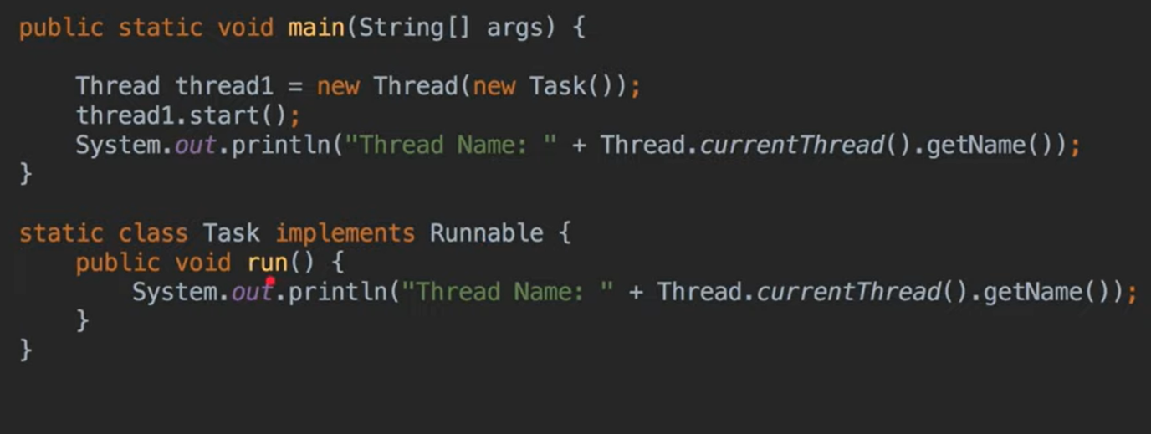

-----------------------2-----------------------------------------

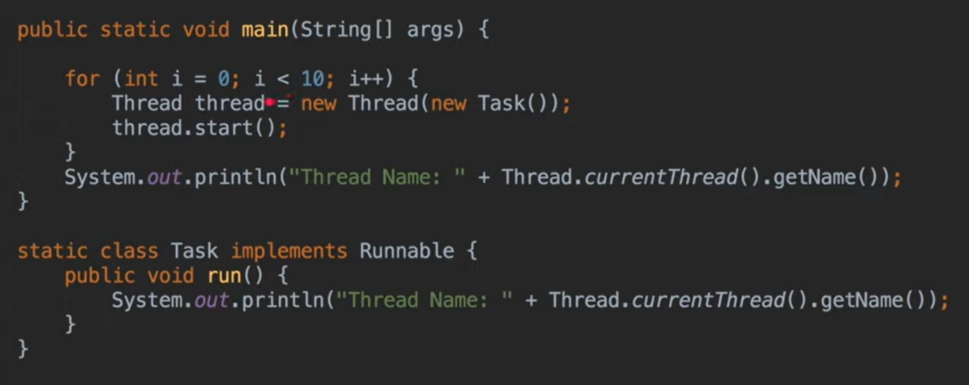

------------------------------3-------------------------------

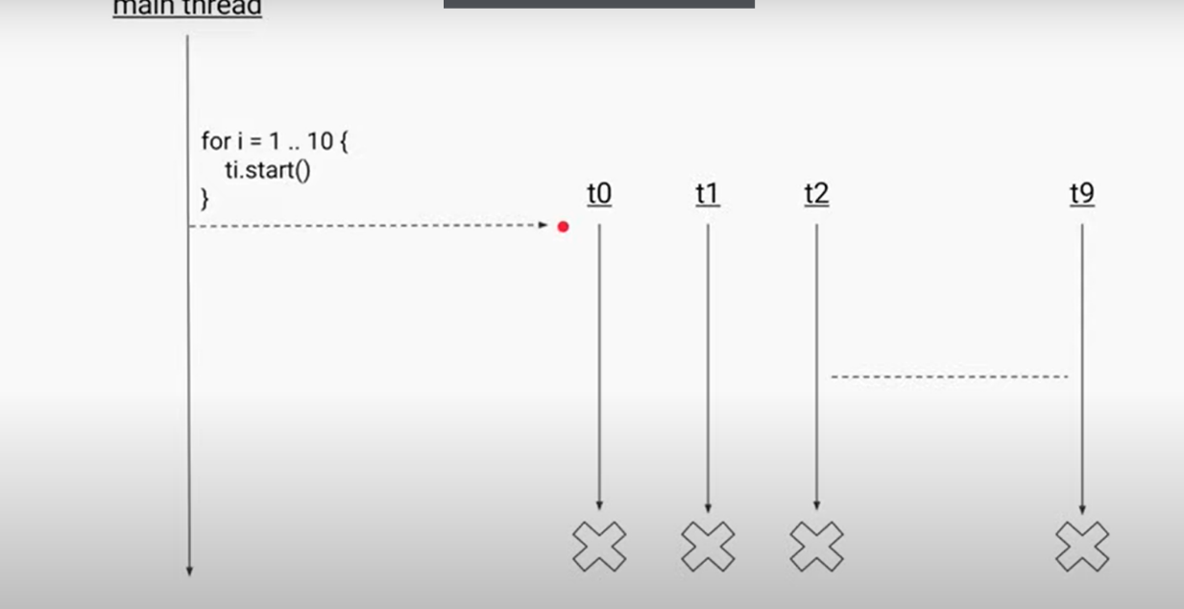

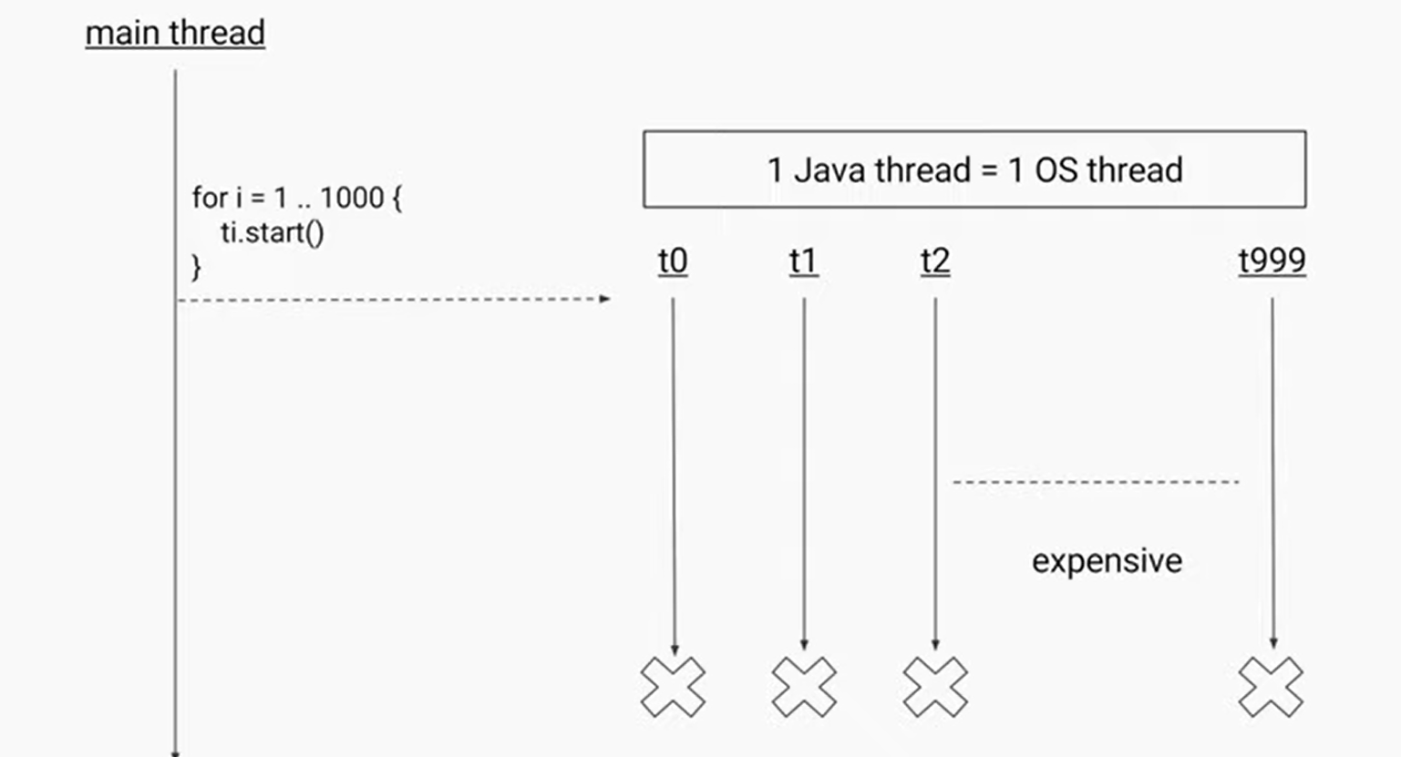

---------------------------4-----------------------------------------

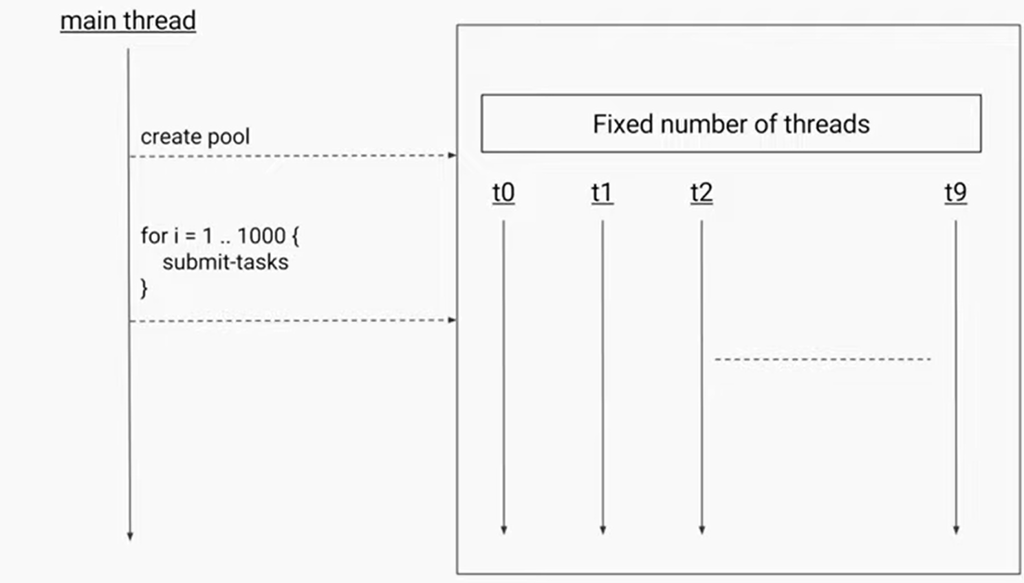

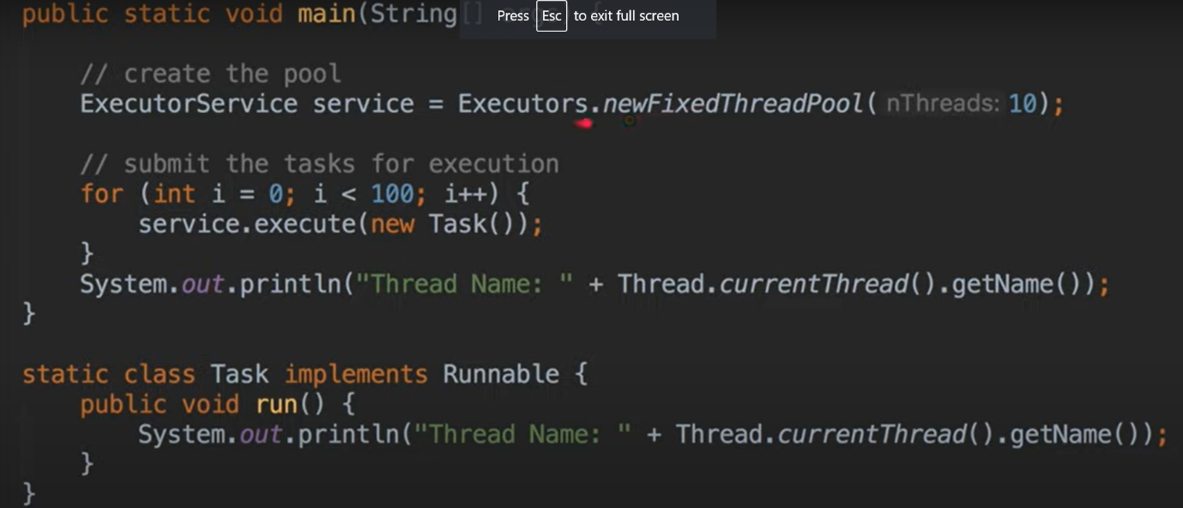

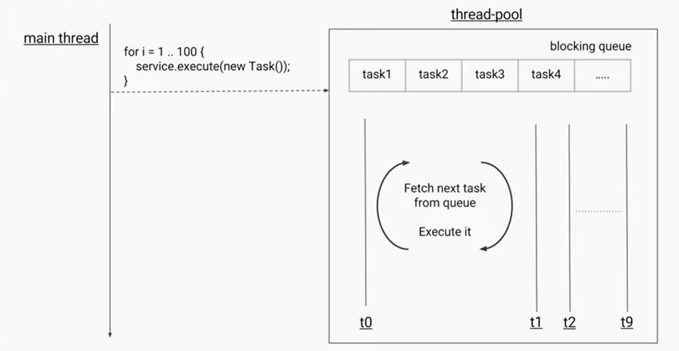

---------------------------------5---------------------------------------------------------------------



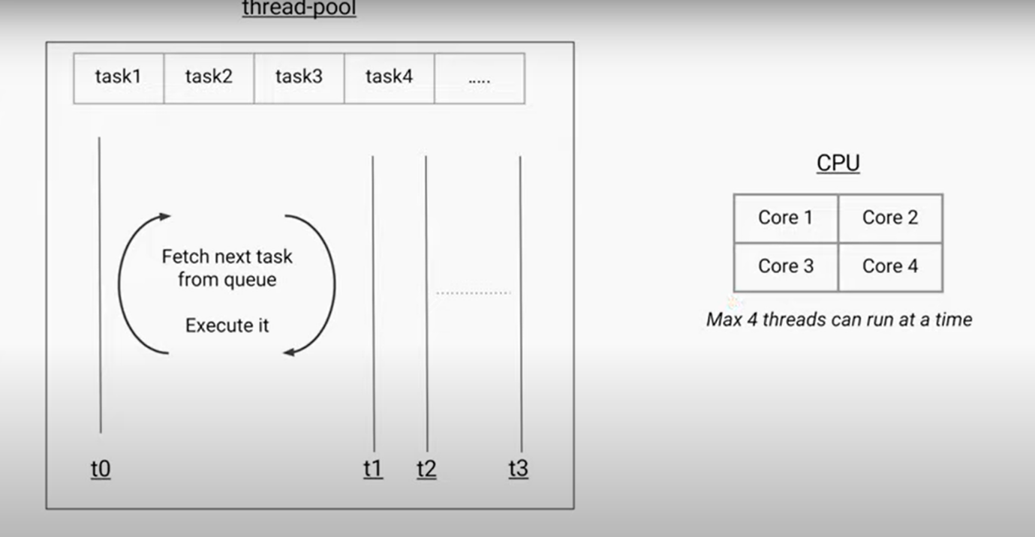

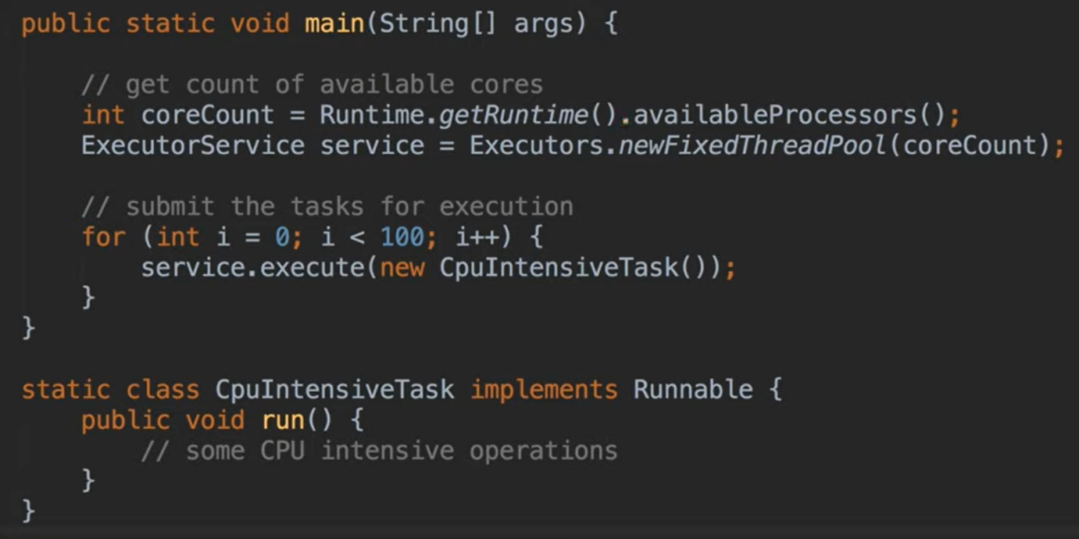

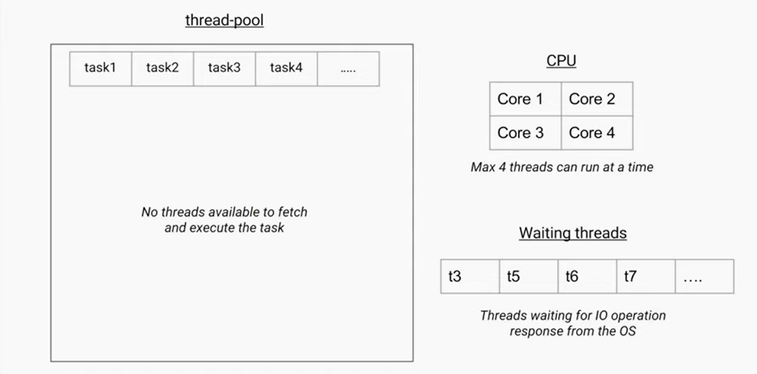

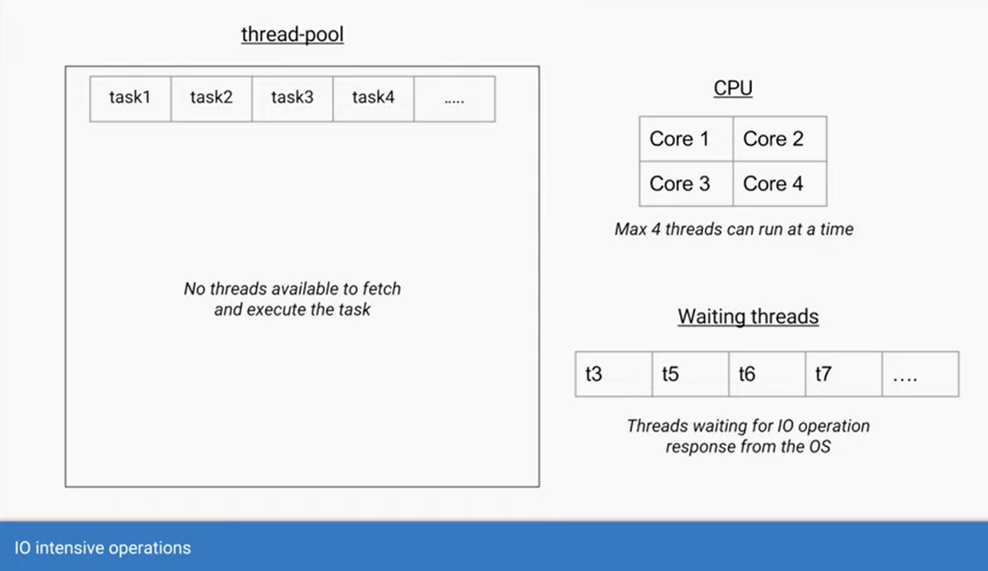

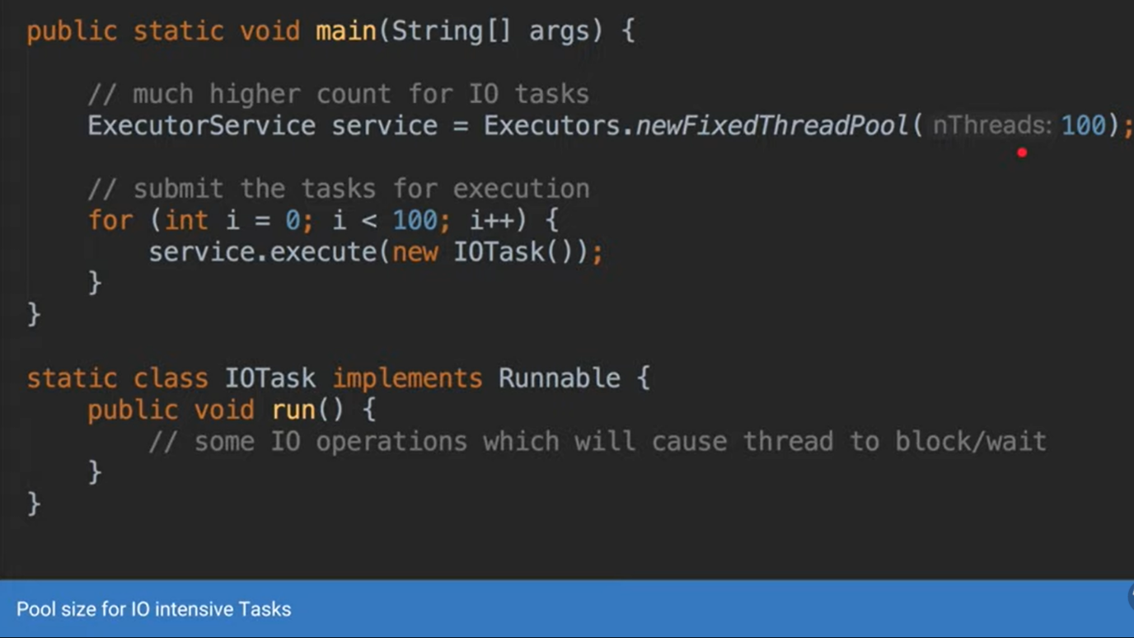

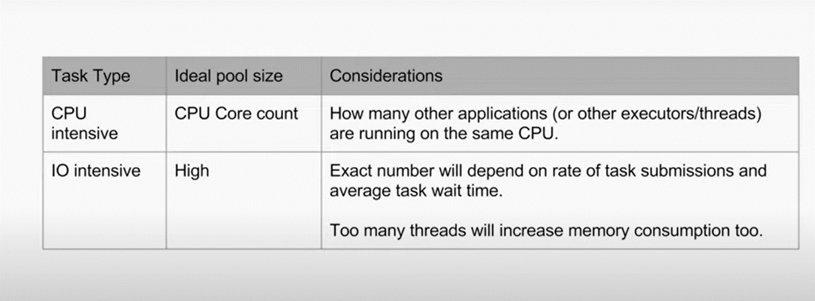

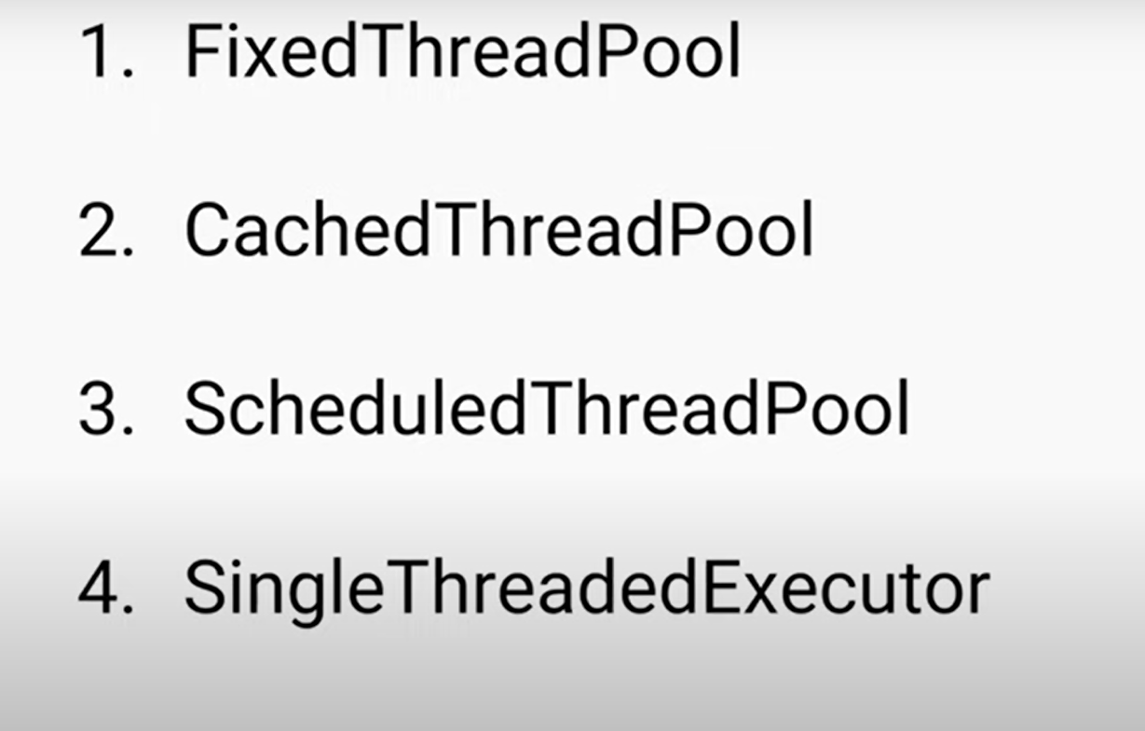

-------------------Fixed Thread Pool------------------------------------

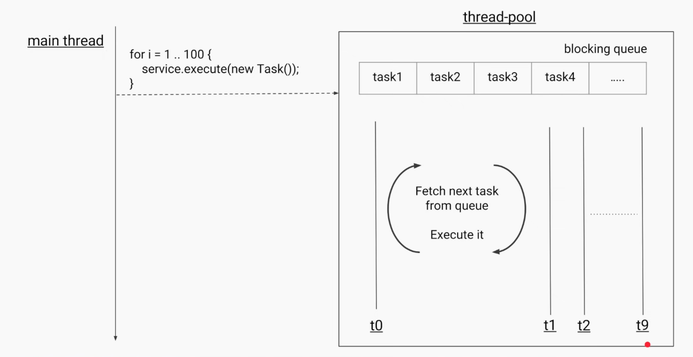

-----------------Cache Thread Pool------------------------------------------

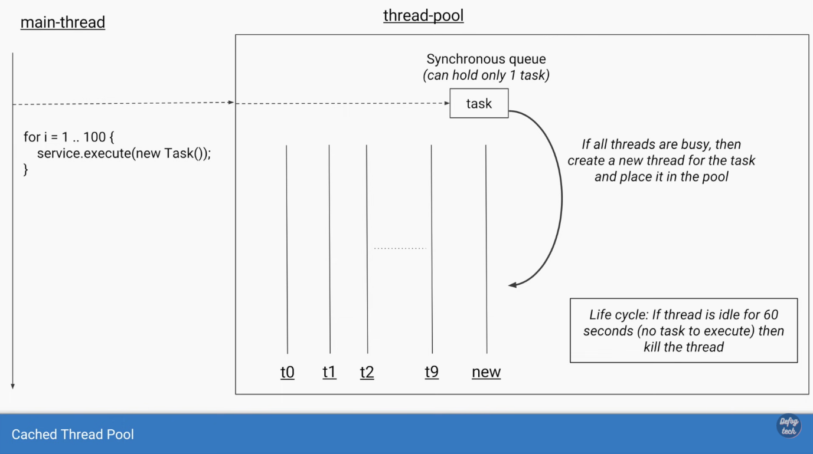

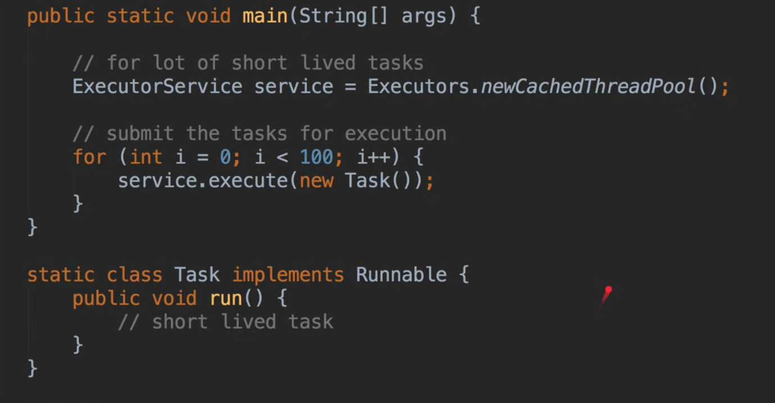

-------------------schedule Thread Pool-------------------------------------------

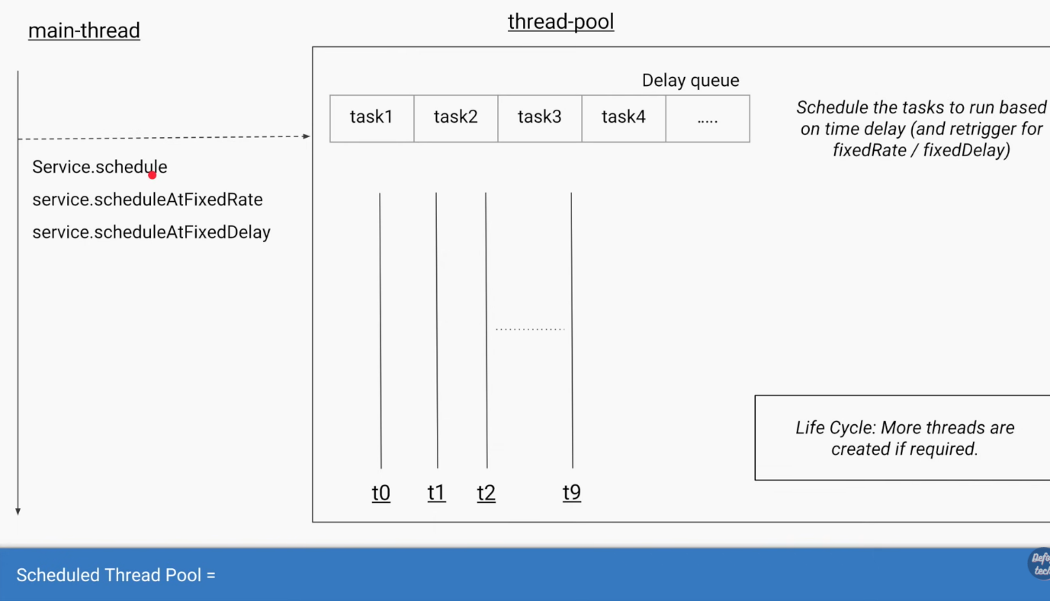

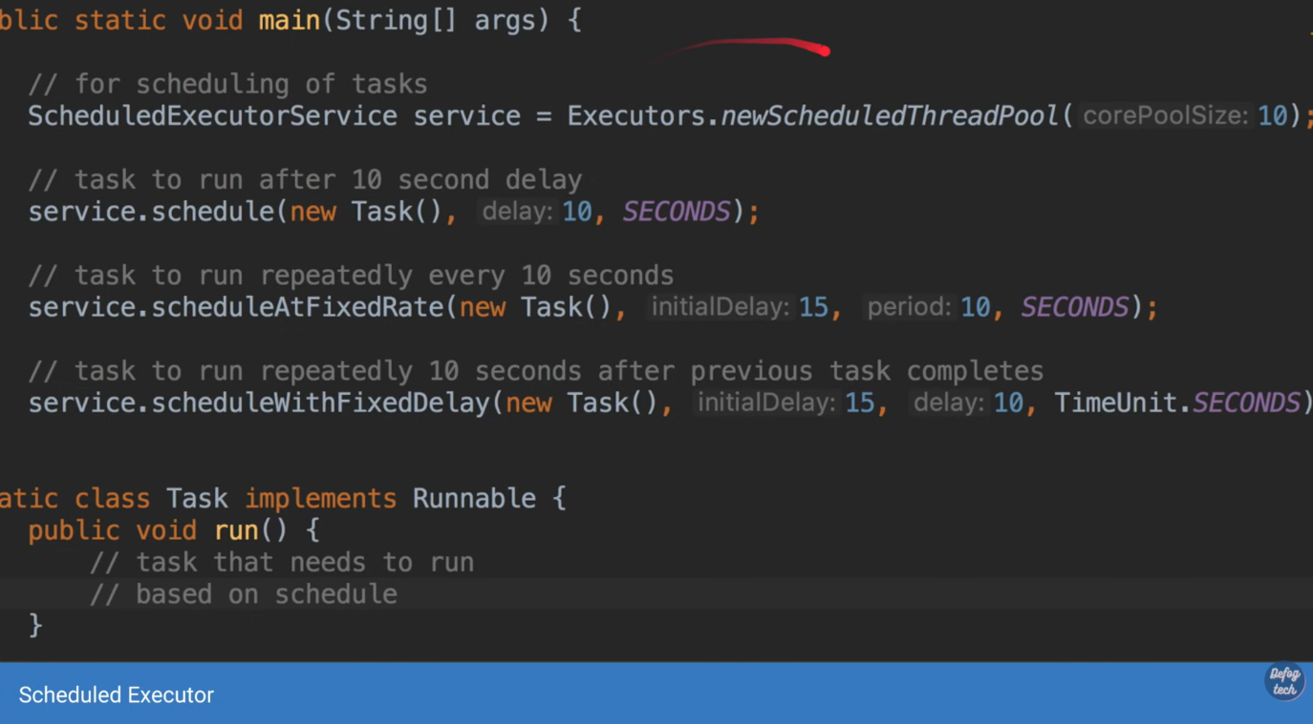

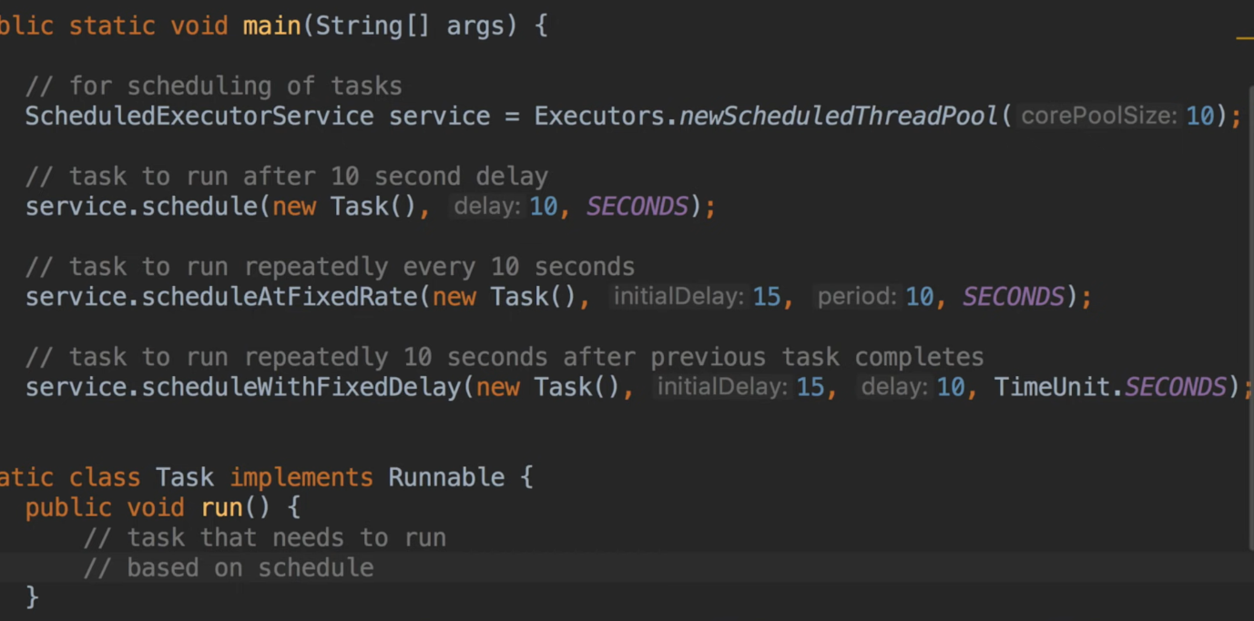

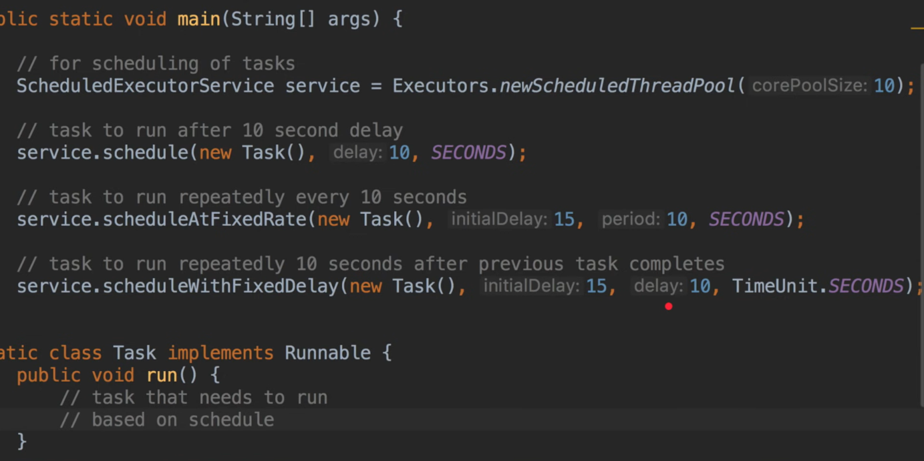

-----------------------------------Sindlethread executor-------------------------

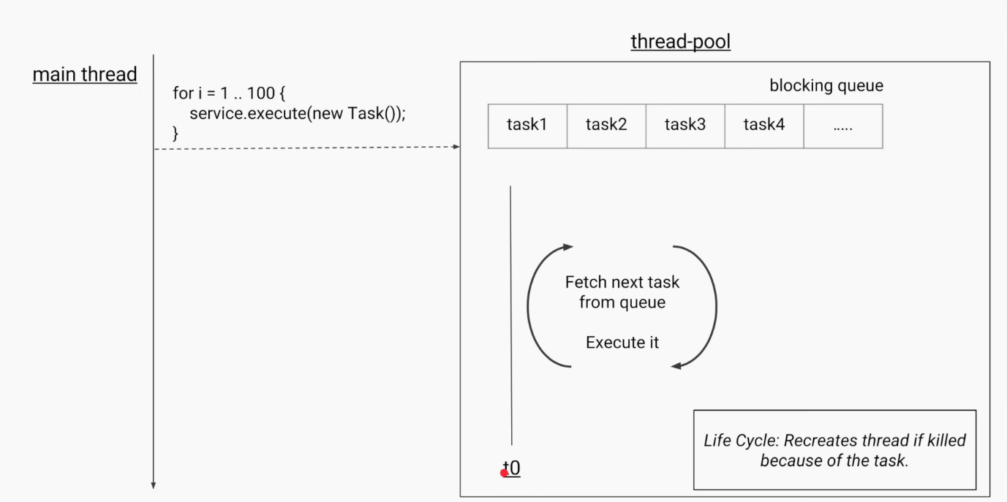

---------------------------Callable--------------------------------

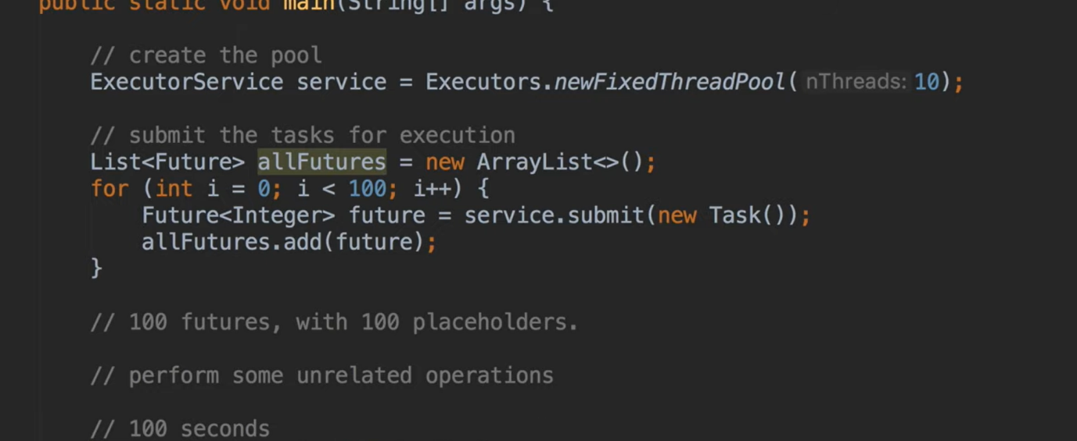

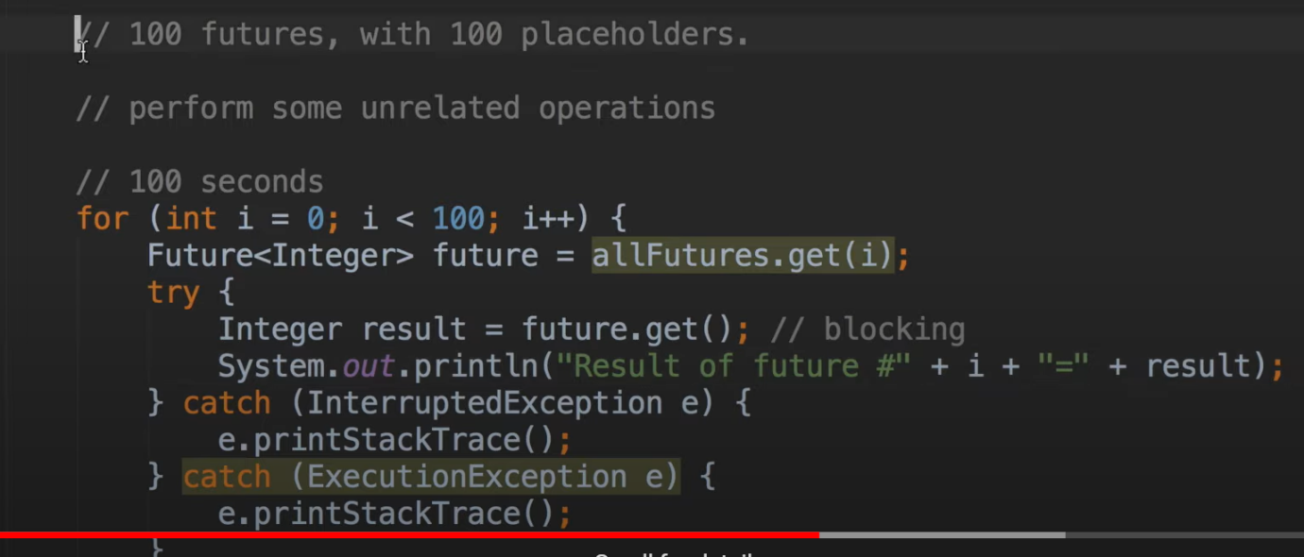

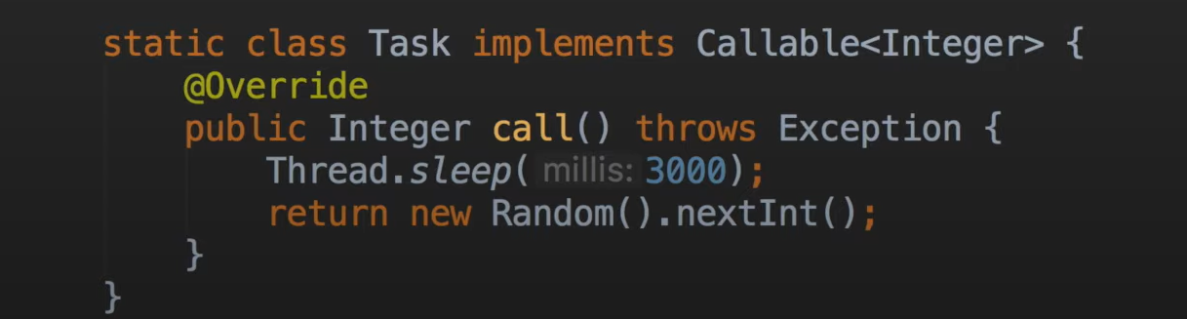

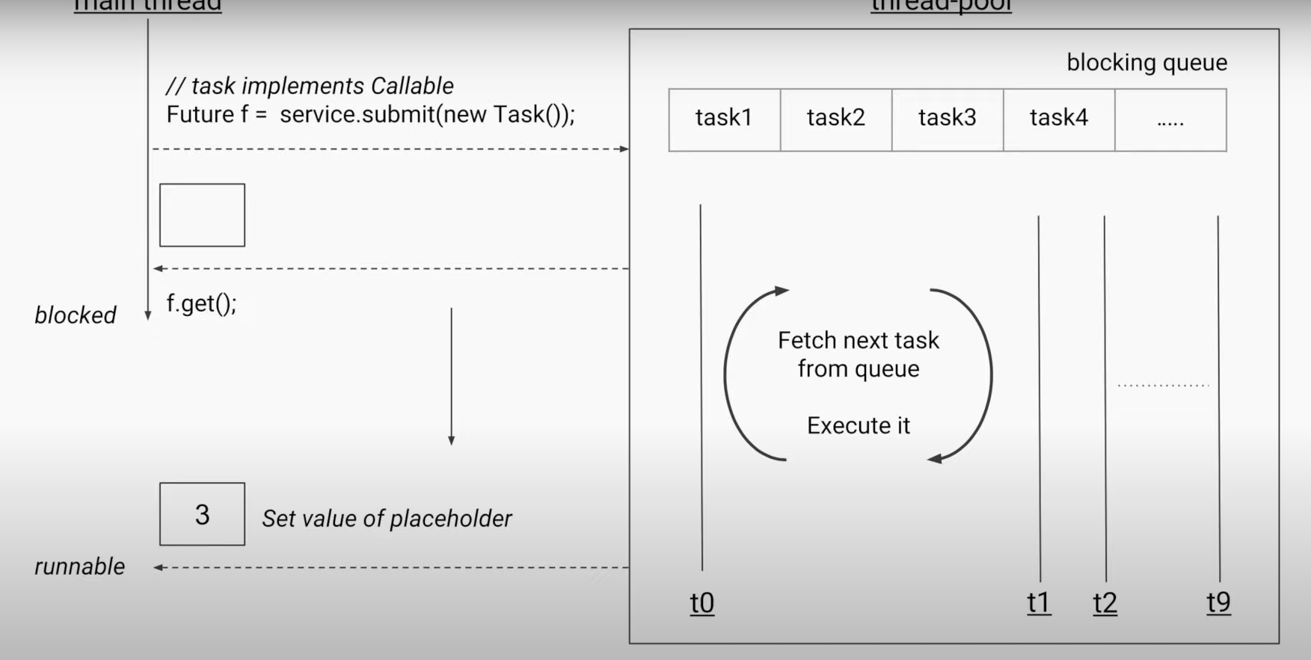

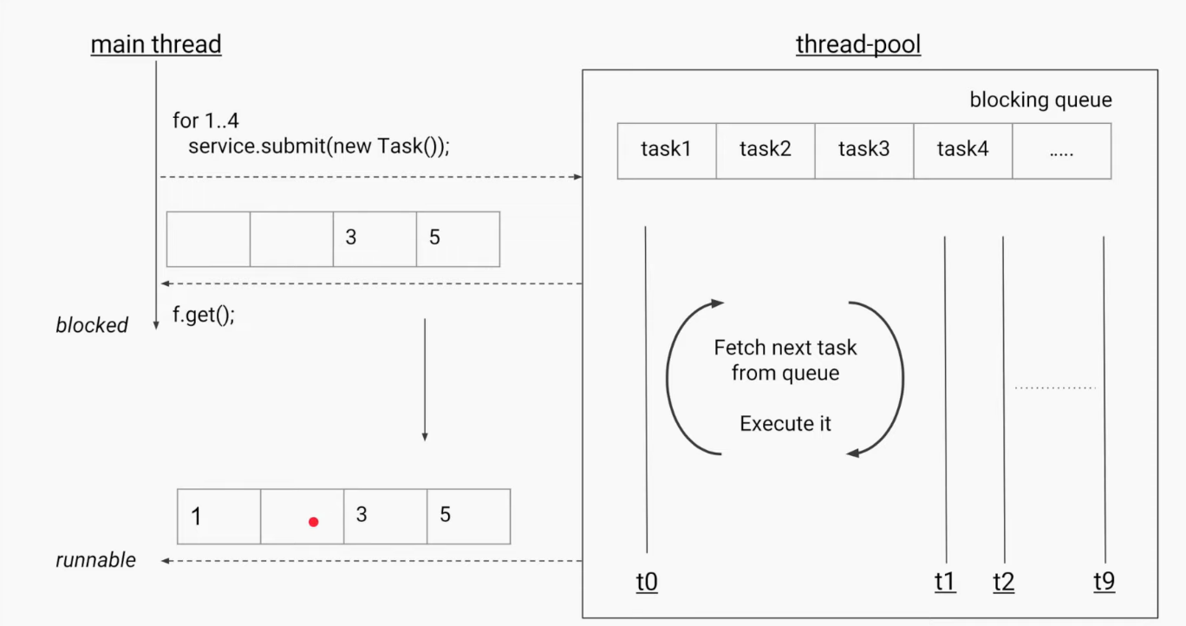

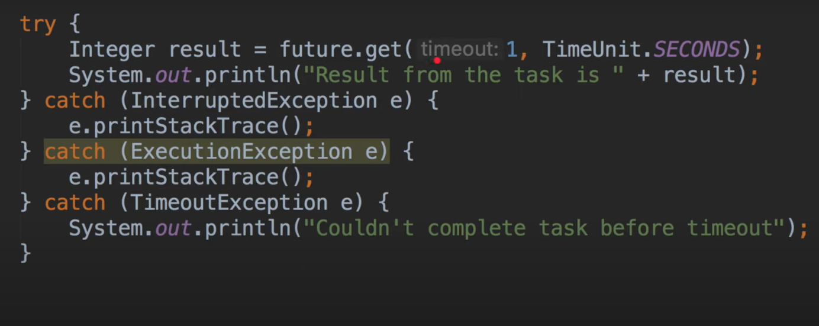

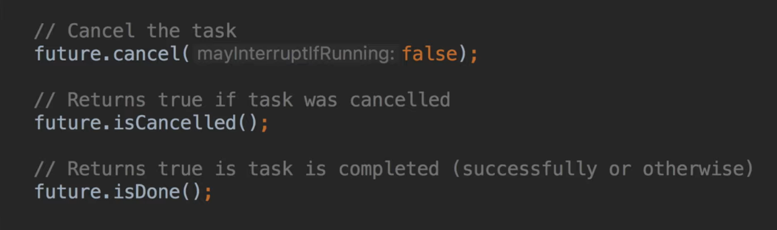

---------------------------------X------------------------------------

How Thread Works?

Java 8 Concurrency tutorial.

* you learn how to execute code in parallel via threads, tasks and executor services.
* Part 1: Threads and Executors
* Part 2: [Synchronization and Locks](https://winterbe.com/posts/2015/04/30/java8-concurrency-tutorial-synchronized-locks-examples/)
* Part 3: [Atomic Variables and ConcurrentMap](https://winterbe.com/posts/2015/05/22/java8-concurrency-tutorial-atomic-concurrent-map-examples/)

-------------------------------------------------------X-------------------------------------------------

* The [Concurrency API](https://docs.oracle.com/javase/8/docs/api/java/util/concurrent/package-summary.html) was first introduced with the release of Java 5 and then progressively enhanced with every new Java release.
* Threads and Runnables[#](https://winterbe.com/posts/2015/04/07/java8-concurrency-tutorial-thread-executor-examples/" \l "threads-and-runnables" \o "Permalink to this section)- All modern operating systems support concurrency both via [processes](http://en.wikipedia.org/wiki/Process_(computing)) and [threads](http://en.wikipedia.org/wiki/Thread_%28computing%29).
* Processes are instances of programs which typically run independent to each other, e.g. if you start a java program the operating system spawns a new process which runs in parallel to other programs.
* Inside those processes we can utilize threads to execute code concurrently, so we can make the most out of the available cores of the CPU.
* Java supports [Threads](https://docs.oracle.com/javase/8/docs/api/java/lang/Thread.html) since JDK 1.0. Before starting a new thread, you have to specify the code to be executed by this thread, often called the task.
* This is done by implementing Runnable - a functional interface defining a single void no-args method run() as demonstrated in the following example:

Runnable task = () -> {

String threadName = Thread.currentThread().getName();

System.out.println("Hello " + threadName);

};

task.run();

Thread thread = new Thread(task);

thread.start();

System.out.println("Done!");

* Since Runnable is a functional interface we can utilize Java 8 lambda expressions to print the current threads name to the console.
* First we execute the runnable directly on the main thread before starting a new thread.
* The result on the console might look like this:

Hello main

Hello Thread-0

Done!

Or that:

Hello main

Done!

Hello Thread-0

* Due to concurrent execution we cannot predict if the runnable will be invoked before or after printing 'done'. The order is non-deterministic, thus making concurrent programming a complex task in larger applications.
* Threads can be put to sleep for a certain duration. This is quite handy to simulate long running tasks in the subsequent code samples of this article:

Runnable runnable = () -> {

try {

String name = Thread.currentThread().getName();

System.out.println("Foo " + name);

TimeUnit.SECONDS.sleep(1);

System.out.println("Bar " + name);

}

catch (InterruptedException e) {

e.printStackTrace();

}

};

Thread thread = new Thread(runnable);

thread.start();

* When you run the above code you'll notice the one second delay between the first and the second print statement.
* TimeUnit is a useful enum for working with units of time. Alternatively you can achieve the same by calling Thread.sleep(1000).
* Working with the Thread class can be very tedious and error-prone. Due to that reason the **Concurrency API** has been introduced back in 2004 with the release of Java 5.
* The API is located in package java.util.concurrent and contains many useful classes for handling concurrent programming.
* Since that time the Concurrency API has been enhanced with every new Java release and even Java 8 provides new classes and methods for dealing with concurrency.
* Now let's take a deeper look at one of the most important parts of the Concurrency API - the executor services.
* Executors-The Concurrency API introduces the concept of an ExecutorService as a higher level replacement for working with threads directly.
* Executors are capable of running asynchronous tasks and typically manage a pool of threads, so we don't have to create new threads manually.
* All threads of the internal pool will be reused under the hood for revenant tasks, so we can run as many concurrent tasks as we want throughout the life-cycle of our application with a single executor service.
* This is how the first thread-example looks like using executors:

ExecutorService executor = Executors.newSingleThreadExecutor();

executor.submit(() -> {

String threadName = Thread.currentThread().getName();

System.out.println("Hello " + threadName);

});

// => Hello pool-1-thread-1

* The class Executors provides convenient factory methods for creating different kinds of executor services.
* In this sample we use an executor with a thread pool of size one.
* The result looks similar to the above sample but when running the code you'll notice an important difference: the java process never stops!
* Executors have to be stopped explicitly - otherwise they keep listening for new tasks.
* An ExecutorService provides two methods for that purpose: shutdown() waits for currently running tasks to finish while shutdownNow() interrupts all running tasks and shut the executor down immediately.
* This is the preferred way how I typically shutdown executors:

try {

System.out.println("attempt to shutdown executor");

executor.shutdown();

executor.awaitTermination(5, TimeUnit.SECONDS);

}

catch (InterruptedException e) {

System.err.println("tasks interrupted");

}

finally {

if (!executor.isTerminated()) {

System.err.println("cancel non-finished tasks");

}

executor.shutdownNow();

System.out.println("shutdown finished");

}

* The executor shuts down softly by waiting a certain amount of time for termination of currently running tasks.
* After a maximum of five seconds the executor finally shuts down by interrupting all running tasks.
* Callables and Futures-In addition to Runnable executors support another kind of task named Callable.
* Callables are functional interfaces just like Runnables but instead of being void they return a value.
* This lambda expression defines a callable returning an integer after sleeping for one second:

Callable<Integer> task = () -> {

try {

TimeUnit.SECONDS.sleep(1);

return 123;

}

catch (InterruptedException e) {

throw new IllegalStateException("task interrupted", e);

}

};

* Callables can be submitted to executor services just like runnables.
* But what about the callables result? Since submit() doesn't wait until the task completes,
* the executor service cannot return the result of the callable directly. Instead the executor returns a special result of type Future which can be used to retrieve the actual result at a later point in time.

ExecutorService executor = Executors.newFixedThreadPool(1);

Future<Integer> future = executor.submit(task);

System.out.println("future done? " + future.isDone());

Integer result = future.get();

System.out.println("future done? " + future.isDone());

System.out.print("result: " + result);

* After submitting the callable to the executor we first check if the future has already been finished execution via isDone().
* I'm pretty sure this isn't the case since the above callable sleeps for one second before returning the integer.
* Calling the method get() blocks the current thread and waits until the callable completes before returning the actual result 123.
* Now the future is finally done and we see the following result on the console:

future done? false

future done? true

result: 123

* Futures are tightly coupled to the underlying executor service. Keep in mind that every non-terminated future will throw exceptions if you shutdown the executor:

executor.shutdownNow();

future.get();

* You might have noticed that the creation of the executor slightly differs from the previous example.
* We use newFixedThreadPool(1) to create an executor service backed by a thread-pool of size one. This is equivalent to newSingleThreadExecutor() but we could later increase the pool size by simply passing a value larger than one.
* Timeouts-Any call to future.get() will block and wait until the underlying callable has been terminated. In the worst case a callable runs forever - thus making your application unresponsive. You can simply counteract those scenarios by passing a timeout:

ExecutorService executor = Executors.newFixedThreadPool(1);

Future<Integer> future = executor.submit(() -> {

try {

TimeUnit.SECONDS.sleep(2);

return 123;

}

catch (InterruptedException e) {

throw new IllegalStateException("task interrupted", e);

}

});

future.get(1, TimeUnit.SECONDS);

* Executing the above code results in a TimeoutException:

Exception in thread "main" java.util.concurrent.TimeoutException

at java.util.concurrent.FutureTask.get(FutureTask.java:205)

* You might already have guessed why this exception is thrown: We specified a maximum wait time of one second but the callable actually needs two seconds before returning the result.
* InvokeAll-Executors support batch submitting of multiple callables at once via invokeAll().
* This method accepts a collection of callables and returns a list of futures.

ExecutorService executor = Executors.newWorkStealingPool();

List<Callable<String>> callables = Arrays.asList(

() -> "task1",

() -> "task2",

() -> "task3");

executor.invokeAll(callables)

.stream()

.map(future -> {

try {

return future.get();

}

catch (Exception e) {

throw new IllegalStateException(e);

}

})

.forEach(System.out::println);

* In this example we utilize Java 8 functional streams in order to process all futures returned by the invocation of invokeAll.
* We first map each future to its return value and then print each value to the console
* InvokeAny-Another way of batch-submitting callables is the method invokeAny() which works slightly different to invokeAll().
* Instead of returning future objects this method blocks until the first callable terminates and returns the result of that callable.
* In order to test this behaviour we use this helper method to simulate callables with different durations. The method returns a callable that sleeps for a certain amount of time until returning the given result:

Callable<String> callable(String result, long sleepSeconds) {

return () -> {

TimeUnit.SECONDS.sleep(sleepSeconds);

return result;

};

}

* We use this method to create a bunch of callables with different durations from one to three seconds.
* Submitting those callables to an executor via invokeAny() returns the string result of the fastest callable - in that case task2:

ExecutorService executor = Executors.newWorkStealingPool();

List<Callable<String>> callables = Arrays.asList(

callable("task1", 2),

callable("task2", 1),

callable("task3", 3));

String result = executor.invokeAny(callables);

System.out.println(result);

// => task2

* The above example uses yet another type of executor created via newWorkStealingPool().
* This factory method is part of Java 8 and returns an executor of type ForkJoinPool which works slightly different than normal executors.
* Instead of using a fixed size thread-pool [ForkJoinPools](https://docs.oracle.com/javase/8/docs/api/java/util/concurrent/ForkJoinPool.html) are created for a given parallelism size which per default is the number of available cores of the hosts CPU.
* ForkJoinPools exist since Java 7
* Scheduled Executors- In order to periodically run common tasks multiple times, we can utilize scheduled thread pools.
* A ScheduledExecutorService is capable of scheduling tasks to run either periodically or once after a certain amount of time has elapsed.
* This code sample schedules a task to run after an initial delay of three seconds has passed:

ScheduledExecutorService executor = Executors.newScheduledThreadPool(1);

Runnable task = () -> System.out.println("Scheduling: " + System.nanoTime());

ScheduledFuture<?> future = executor.schedule(task, 3, TimeUnit.SECONDS);

TimeUnit.MILLISECONDS.sleep(1337);

long remainingDelay = future.getDelay(TimeUnit.MILLISECONDS);

System.out.printf("Remaining Delay: %sms", remainingDelay);

* Scheduling a task produces a specialized future of type ScheduledFuture which - in addition to Future - provides the method getDelay() to retrieve the remaining delay.
* After this delay has elapsed the task will be executed concurrently.
* In order to schedule tasks to be executed periodically, executors provide the two methods scheduleAtFixedRate() and scheduleWithFixedDelay().
* The first method is capable of executing tasks with a fixed time rate, e.g. once every second as demonstrated in this example:

ScheduledExecutorService executor = Executors.newScheduledThreadPool(1);

Runnable task = () -> System.out.println("Scheduling: " + System.nanoTime());

int initialDelay = 0;

int period = 1;

executor.scheduleAtFixedRate(task, initialDelay, period, TimeUnit.SECONDS);

* Additionally this method accepts an initial delay which describes the leading wait time before the task will be executed for the first time.
* Please keep in mind that scheduleAtFixedRate() doesn't take into account the actual duration of the task.
* So if you specify a period of one second but the task needs 2 seconds to be executed then the thread pool will working to capacity very soon.
* In that case you should consider using scheduleWithFixedDelay() instead.
* This method works just like the counterpart described above.
* The difference is that the wait time period applies between the end of a task and the start of the next task. For example:

ScheduledExecutorService executor = Executors.newScheduledThreadPool(1);

Runnable task = () -> {

try {

TimeUnit.SECONDS.sleep(2);

System.out.println("Scheduling: " + System.nanoTime());

}

catch (InterruptedException e) {

System.err.println("task interrupted");

}

};

executor.scheduleWithFixedDelay(task, 0, 1, TimeUnit.SECONDS);

* This example schedules a task with a fixed delay of one second between the end of an execution and the start of the next execution.
* The initial delay is zero and the tasks duration is two seconds. So we end up with an execution interval of 0s, 3s, 6s, 9s and so on.
* As you can see scheduleWithFixedDelay() is handy if you cannot predict the duration of the scheduled tasks.

**-------------------------------------------X----------------------------------------------------------**

**How Array List Works?**

Ans:-

* **Amortized complexity is** the total expense per operation, evaluated over a sequence of operations.
* The idea is to guarantee the total expense of the entire sequence, while permitting individual operations to be much more expensive than the amortized cost.
* **Example:**  
  onsider a [dynamic array](https://en.wikipedia.org/wiki/Dynamic_array) that grows in size as more elements are added to it, such as ArrayList in Java or std::vector in C++.
* If we started out with a dynamic array of size 4, we could push 4 elements onto it, and each operation would take [constant time](https://en.wikipedia.org/wiki/Constant_time).
* Yet pushing a fifth element onto that array would take longer as the array would have to create a new array of double the current size (8), copy the old elements onto the new array, and then add the new element.
* The next three push operations would similarly take constant time, and then the subsequent addition would require another slow doubling of the array size.
* In general if we consider an arbitrary number of pushes *n* + 1 to an array of size *n*, we notice that push operations take constant time except for the last one which takes [{\displaystyle \Theta (n)}](https://en.wikipedia.org/wiki/Big_O_notation) time to perform the size doubling operation.
* Since there were *n* + 1 operations total we can take the average of this and find that pushing elements onto the dynamic array takes: {\displaystyle {\tfrac {n\Theta (1)+\Theta (n)}{n+1}}=\Theta (1)}, constant time.[[4]](https://en.wikipedia.org/wiki/Amortized_analysis#cite_note-Lecture_20-4)
* Resizable-array implementation of the List interface. Implements all optional list operations, and permits all elements, including null. In addition to implementing the List interface, this class provides methods to manipulate the size of the array that is used internally to store the list. (This class is roughly equivalent to Vector, except that it is unsynchronized.)
* The size, isEmpty, get, set, iterator, and listIterator operations run in constant time.
* The add operation runs in *amortized constant time*, that is, adding n elements requires O(n) time.
* All of the other operations run in linear time (roughly speaking). The constant factor is low compared to that for the LinkedList implementation.
* Each ArrayList instance has a *capacity*. The capacity is the size of the array used to store the elements in the list.
* It is always at least as large as the list size. As elements are added to an ArrayList, its capacity grows automatically. The details of the growth policy are not specified beyond the fact that adding an element has constant amortized time cost.
* An application can increase the capacity of an ArrayList instance before adding a large number of elements using the ensureCapacity operation.
* This may reduce the amount of incremental reallocation.
* **Note that this implementation is not synchronized.** If multiple threads access an ArrayList instance concurrently, and at least one of the threads modifies the list structurally, it *must* be synchronized externally.
* (A structural modification is any operation that adds or deletes one or more elements, or explicitly resizes the backing array; merely setting the value of an element is not a structural modification.)
* This is typically accomplished by synchronizing on some object that naturally encapsulates the list. If no such object exists, the list should be "wrapped" using the [Collections.synchronizedList](https://docs.oracle.com/javase/8/docs/api/java/util/Collections.html#synchronizedList-java.util.List-) method. This is best done at creation time, to prevent accidental unsynchronized access to the list:

**List list = Collections.synchronizedList(new ArrayList(...));**

* The iterators returned by this class's [iterator](https://docs.oracle.com/javase/8/docs/api/java/util/ArrayList.html" \l "iterator--) and [listIterator](https://docs.oracle.com/javase/8/docs/api/java/util/ArrayList.html#listIterator-int-) methods are *fail-fast*: if the list is structurally modified at any time after the iterator is created, in any way except through the iterator's own [remove](https://docs.oracle.com/javase/8/docs/api/java/util/ListIterator.html#remove--) or [add](https://docs.oracle.com/javase/8/docs/api/java/util/ListIterator.html#add-E-) methods, the iterator will throw a [ConcurrentModificationException](https://docs.oracle.com/javase/8/docs/api/java/util/ConcurrentModificationException.html). Thus, in the face of concurrent modification, the iterator fails quickly and cleanly, rather than risking arbitrary, non-deterministic behavior at an undetermined time in the future.
* Note that the fail-fast behavior of an iterator cannot be guaranteed as it is, generally speaking, impossible to make any hard guarantees in the presence of unsynchronized concurrent modification. Fail-fast iterators throw ConcurrentModificationException on a best-effort basis. Therefore, it would be wrong to write a program that depended on this exception for its correctness: *the fail-fast behavior of iterators should be used only to detect bugs.*

---------------------------------------X----------------------------------------------

**What is Fail-fast and Fail safe?**

Ans-

* **Fail**-**Safe**. 1. Exception. Any changes in the collection, such as adding, removing and updating collection during a thread are iterating collection then **Fail fast** throw concurrent modification exception.
* The **fail**-**safe** collection doesn't throw exception
* in [systems design](https://en.wikipedia.org/wiki/Systems_design), a **fail-fast** system is one which immediately reports at its interface any condition that is likely to indicate a failure.
* Fail-fast systems are usually designed to stop normal operation rather than attempt to continue a possibly flawed process.
* Such designs often check the system's state at several points in an operation, so any failures can be detected early.
* The responsibility of a fail-fast module is detecting errors, then letting the next-highest level of the system handle them.

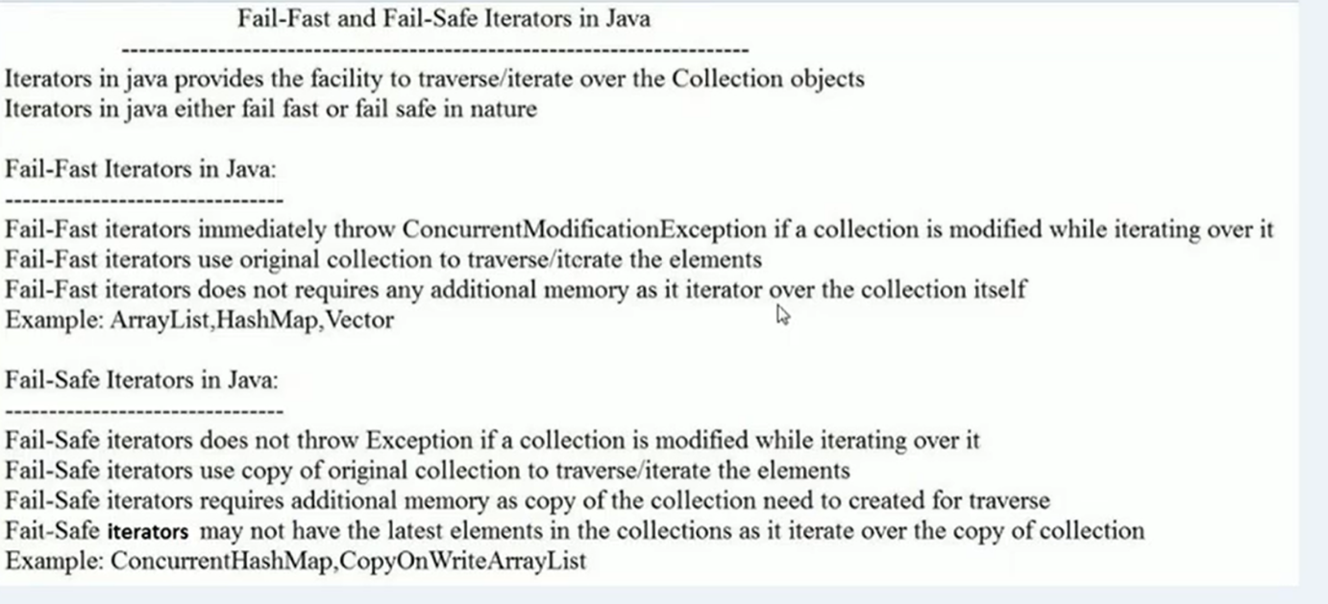

----------------------Demo On Fail fast in Java----------------------------

Fail-Fast

**while**(it.hasNext())

{

System.***out***.print(" : "+ it.next());

//intList.add(100);//will get concur modifiable

//exception because it is structural change

intList.set(2, 222);//no exception because of structural change

}

Fail safe

List<Integer> intList=**new** CopyOnWriteArrayList<Integer>();

------------------------------X--------------------------

What is singleton design pattern? And how to break that pattern?

Ans-

